Automation Name - Admin-CRMAHealthCheck
Path - my automations/26. Reports/B. Daily
screenshots –
Summary tab -
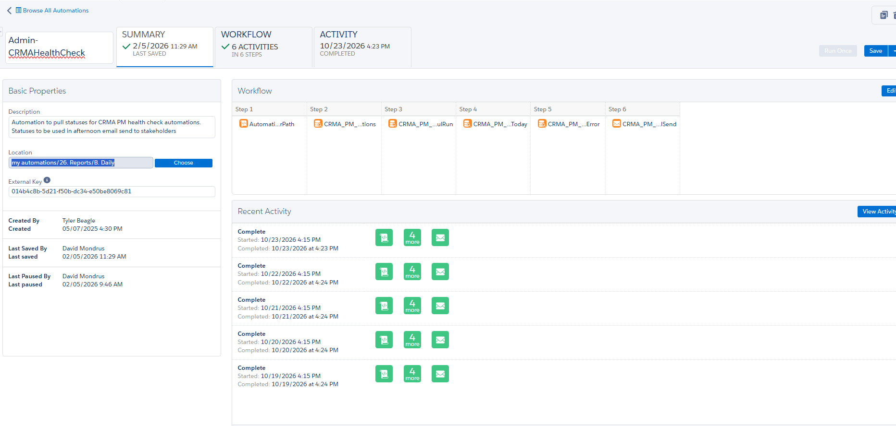

Workflow tab- 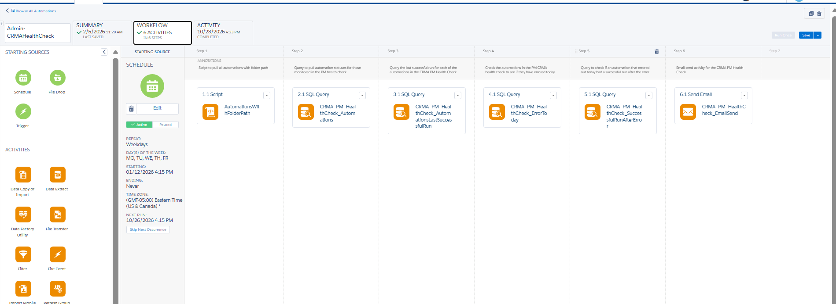

Activity Tab -
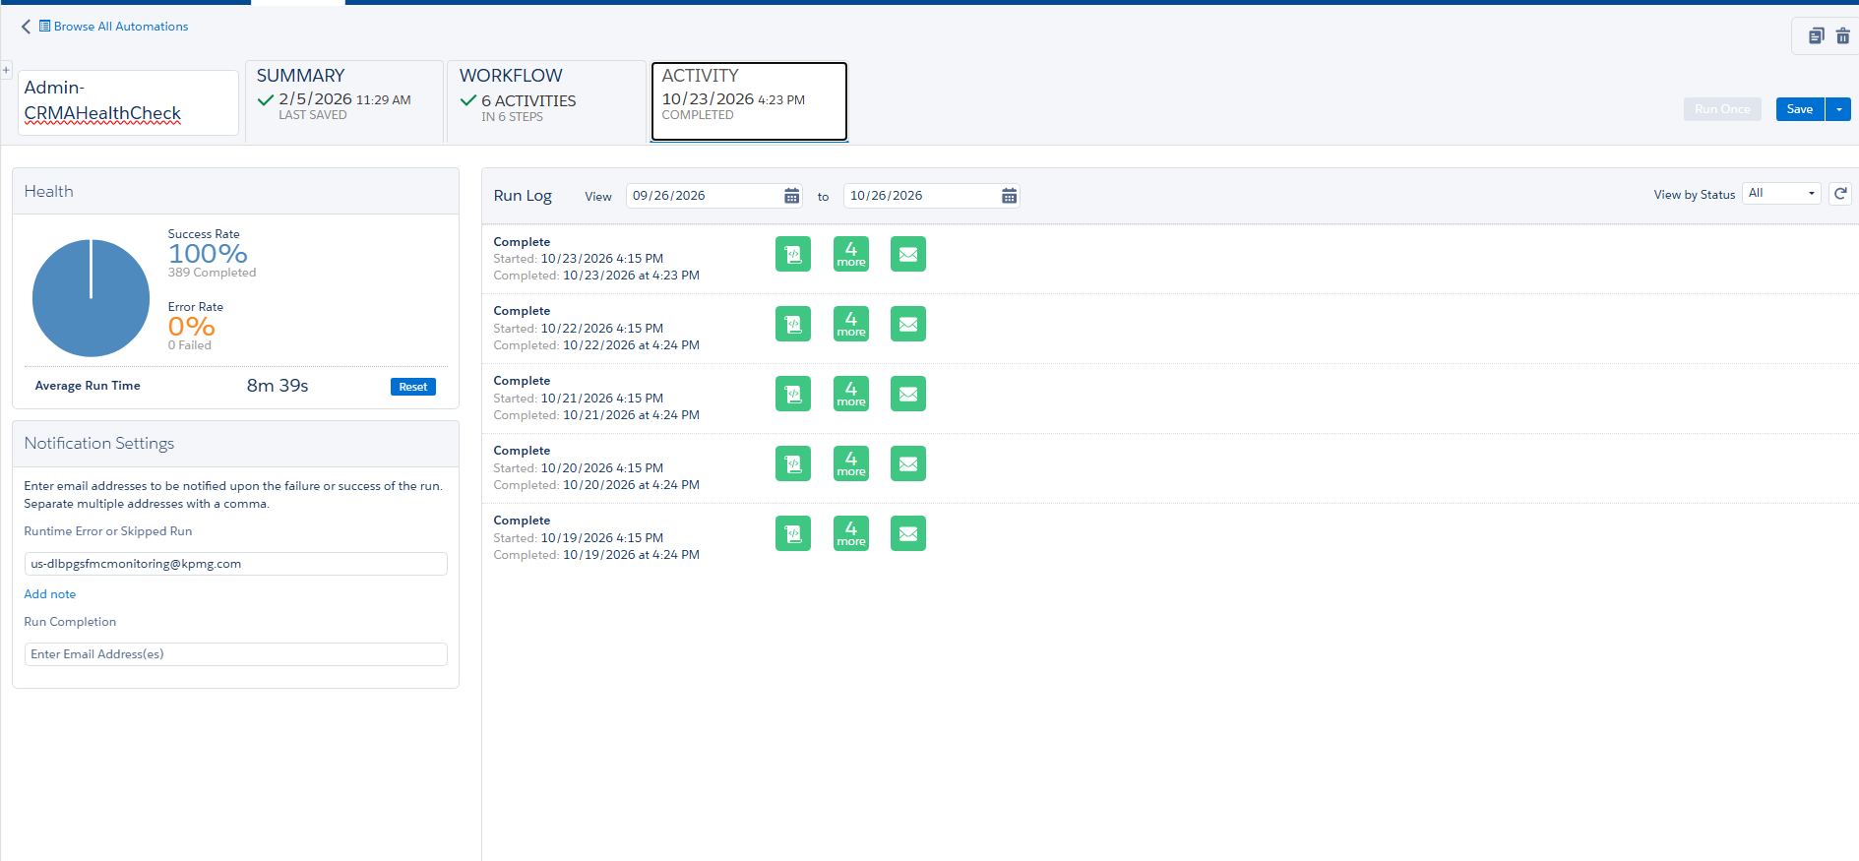

Includes – 6 steps
Step 1 – Script activity .
Screenshots-
Summary tab-
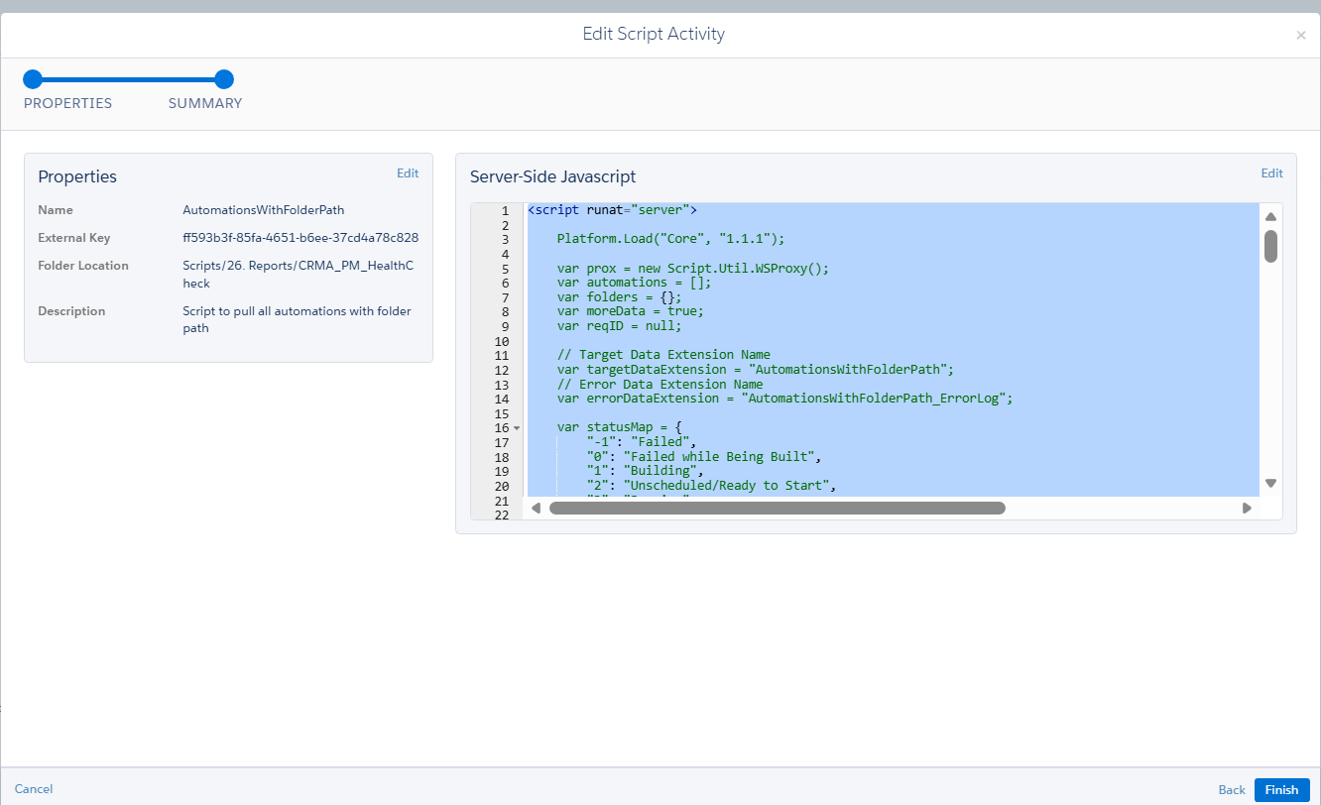

Properties tab -
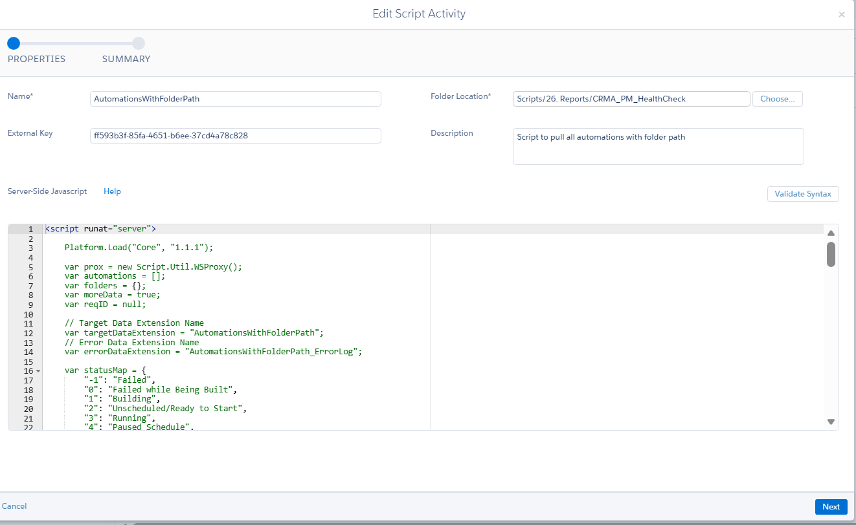

Step 2- SQL Query
- SELECT
- CustomerKey AS AutomationCustomerKey,
- Name AS AutomationName,
- Status AS AutomationStatus,
- CAST(GETDATE() AS DATE) AS [Date]
- FROM [AutomationsWithFolderPath]
- WHERE Name IN (
- SELECT AutomationName
- FROM [CRMA_PM_HealthCheck_Automations]
- )
Screenshot -
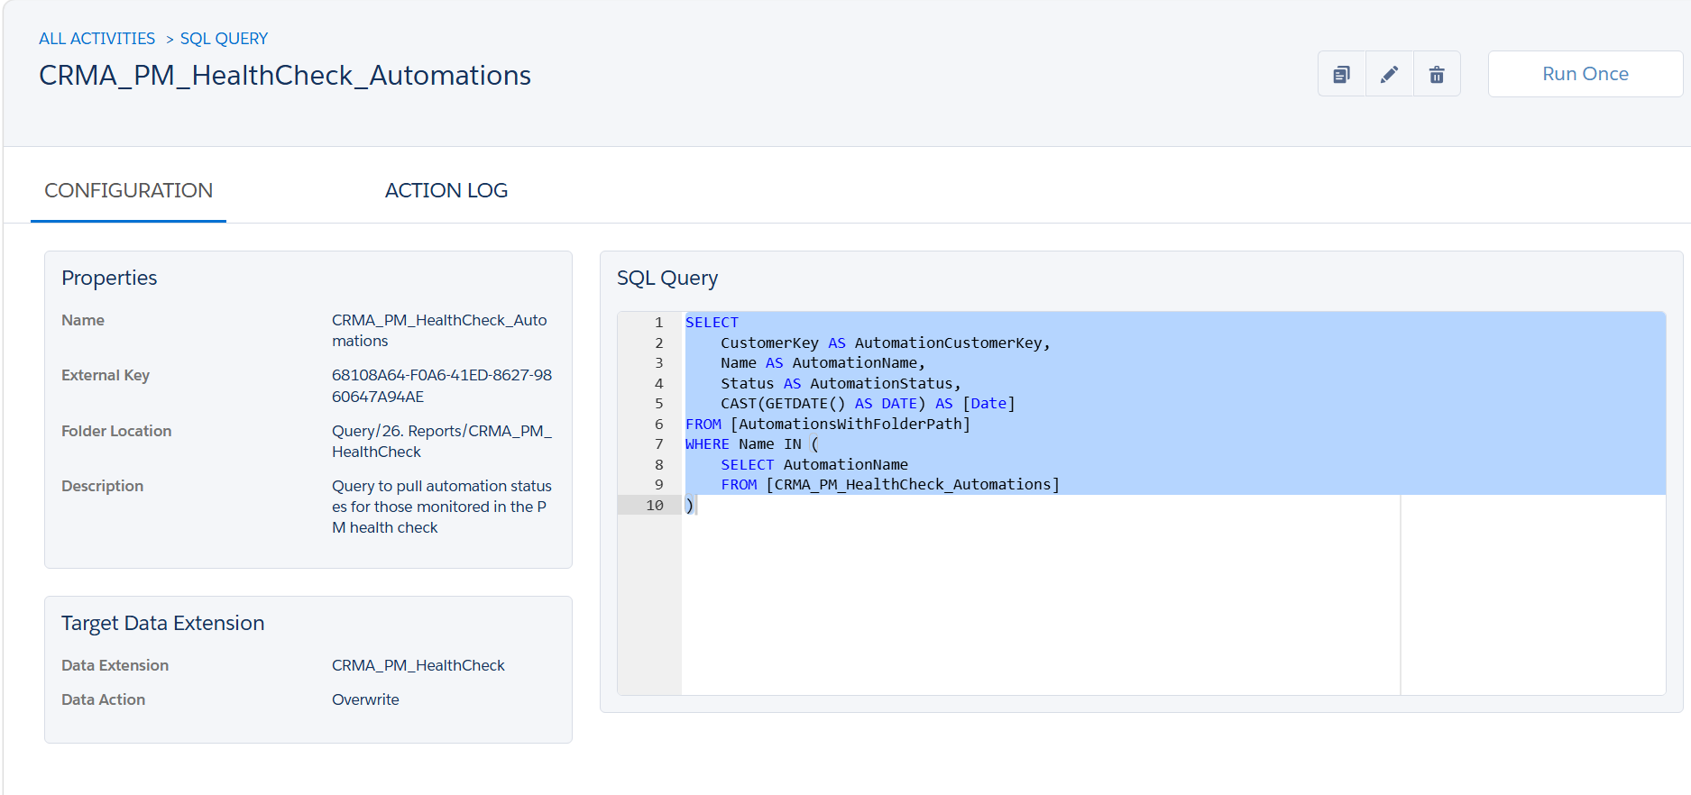
Data Extensions :
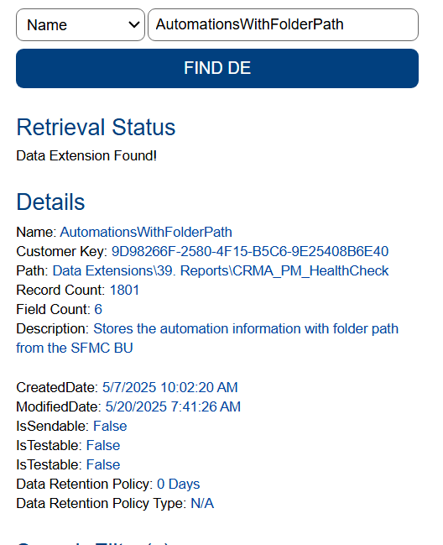

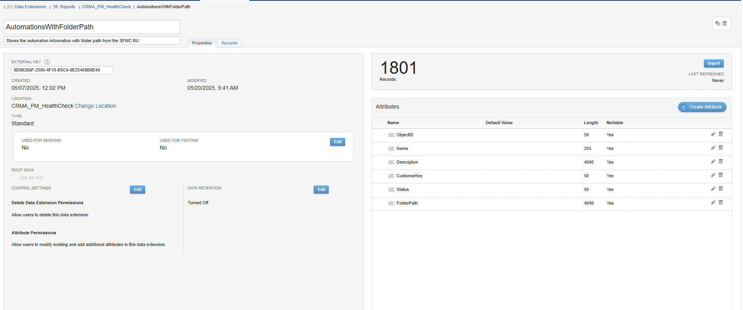
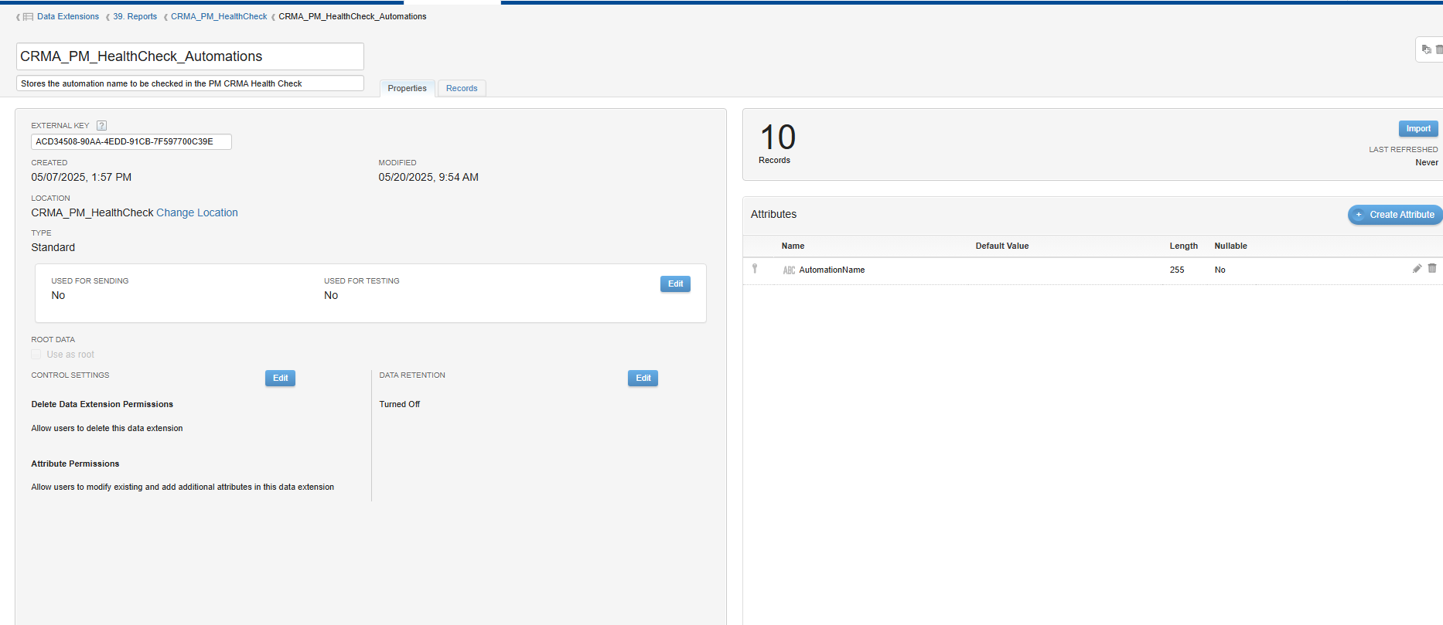

Target DE-
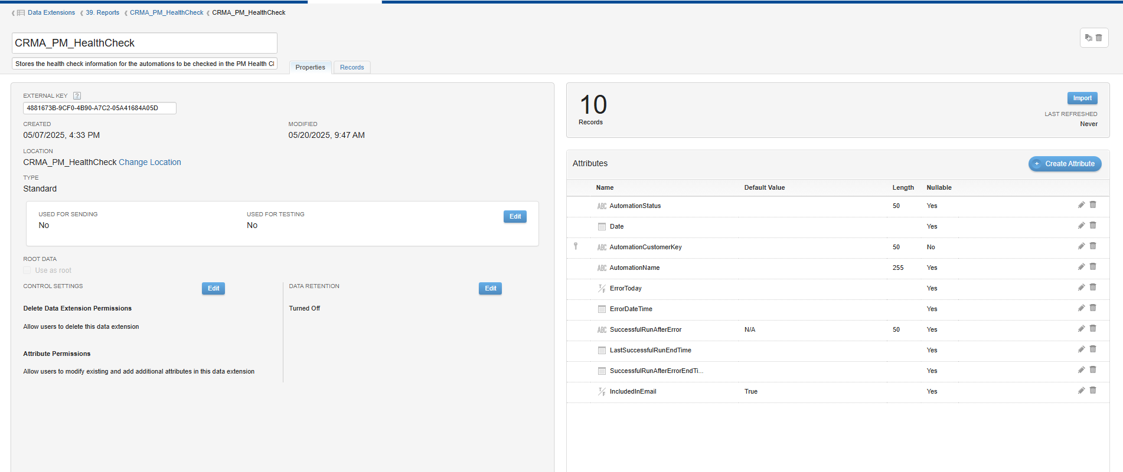
Step 3- SQL Query
- SELECT
- ai.AutomationCustomerKey,
- DATEADD(HOUR, -4, MAX(ai.AutomationInstanceEndTime_UTC)) AS LastSuccessfulRunEndTime
- FROM
- _AutomationInstance ai
- WHERE
- ai.AutomationInstanceStatus = 'Complete'
- AND ai.AutomationCustomerKey IN (SELECT AutomationCustomerKey FROM CRMA_PM_HealthCheck)
- GROUP BY
- ai.AutomationCustomerKey

Screenshot-
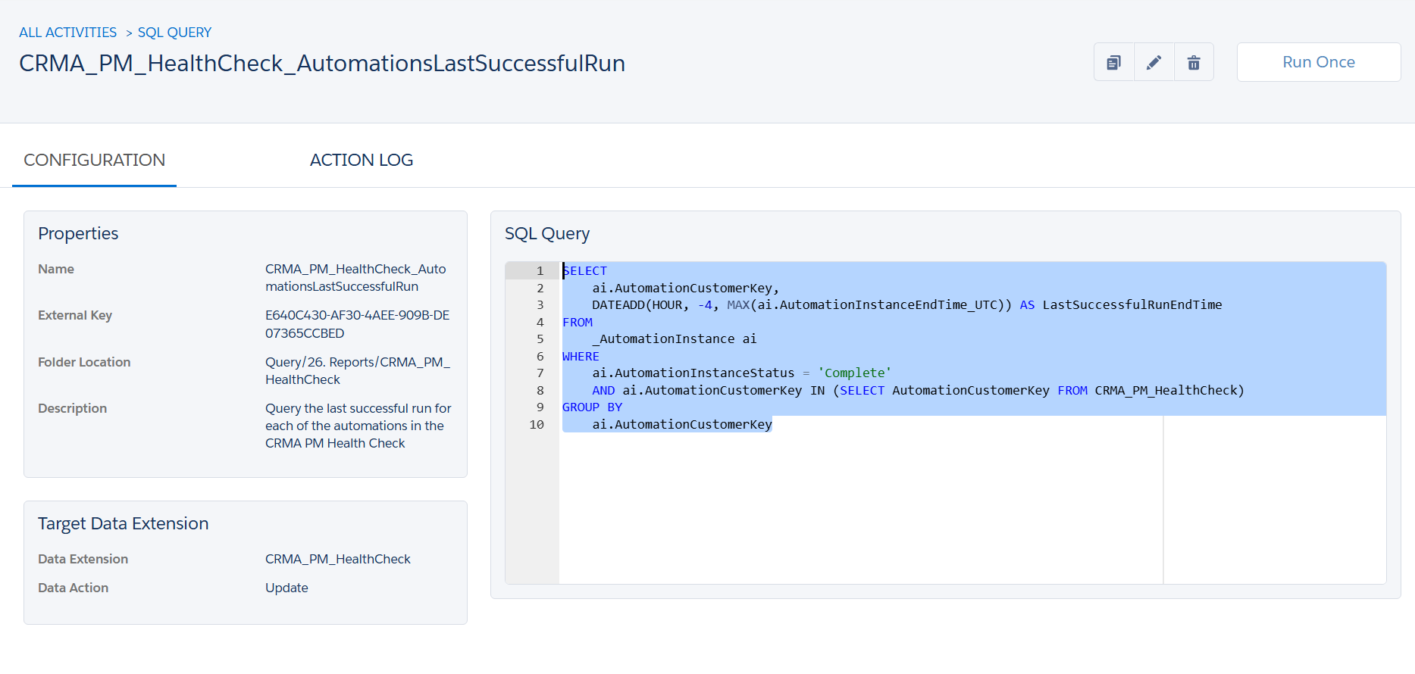
Data extensions:
Source-
And _AutomationInstance as Data View
Target-
Step 4- SQL Query
- SELECT
- hc.AutomationCustomerKey,
- hc.AutomationName,
- hc.AutomationStatus,
- CASE
- WHEN re.AutomationInstanceID IS NOT NULL
- THEN 'True'
- ELSE 'False'
- END AS ErrorToday,
- DATEADD(HOUR, -4, re.AutomationInstanceEndTime_UTC) AS ErrorDateTime,
- hc.[Date]
- FROM
- [CRMA_PM_HealthCheck] hc
- LEFT JOIN (
- SELECT
- ai.AutomationCustomerKey,
- ai.AutomationInstanceID,
- ai.AutomationInstanceEndTime_UTC
- FROM [_AutomationInstance] ai
- INNER JOIN (
- SELECT
- AutomationCustomerKey,
- MAX(AutomationInstanceEndTime_UTC) AS MaxEndTime
- FROM [_AutomationInstance]
- WHERE AutomationInstanceStatus = 'Error'
- AND CAST(AutomationInstanceEndTime_UTC AS DATE) = CAST(GETUTCDATE() AS DATE)
- AND CAST(DATEADD(HOUR, -4, AutomationInstanceEndTime_UTC) AS DATE) = CAST(GETDATE() AS DATE)
- GROUP BY AutomationCustomerKey
- ) le
- ON ai.AutomationCustomerKey = le.AutomationCustomerKey
- AND ai.AutomationInstanceEndTime_UTC = le.MaxEndTime
- WHERE ai.AutomationInstanceStatus = 'Error'
- AND CAST(ai.AutomationInstanceEndTime_UTC AS DATE) = CAST(GETUTCDATE() AS DATE)
- ) re
- ON hc.AutomationCustomerKey = re.AutomationCustomerKey
Screenshot -
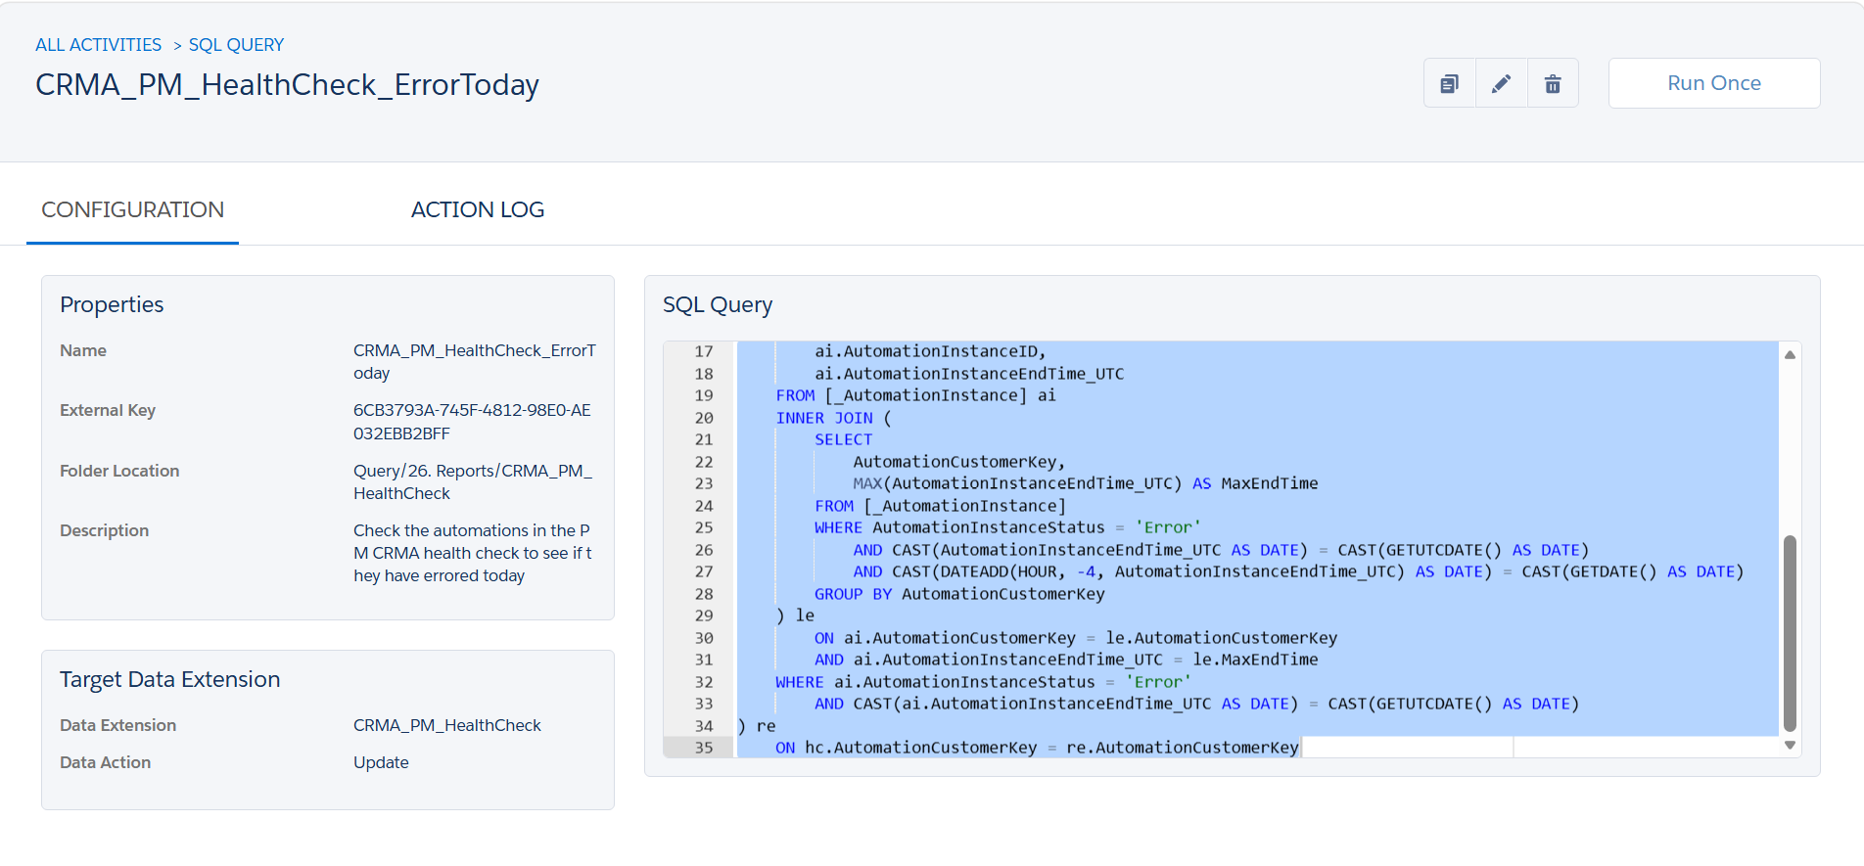
Screenshots-
Source-
And _AutomationInstance as data view
Target-
Data action - Update
Step 5- SQL Query
- SELECT
- hc.AutomationCustomerKey,
- hc.AutomationName,
- hc.AutomationStatus,
- CASE
- WHEN ai.AutomationInstanceID IS NOT NULL
- THEN 'Yes'
- ELSE 'No'
- END AS SuccessfulRunAfterError,
- hc.ErrorToday,
- hc.ErrorDateTime,
- DATEADD(HOUR, -4, CAST(ai.FirstSuccessEndTime AS DATETIME)) AS SuccessfulRunAfterErrorEndTime,
- hc.[Date],
- hc.LastSuccessfulRunEndTime
- FROM
- [CRMA_PM_HealthCheck] hc
- LEFT JOIN (
- SELECT
- ai.AutomationCustomerKey,
- ai.AutomationInstanceID,
- MIN(ai.AutomationInstanceEndTime_UTC) AS FirstSuccessEndTime
- FROM
- [_AutomationInstance] ai
- JOIN [CRMA_PM_HealthCheck] hc2
- ON hc2.AutomationCustomerKey = ai.AutomationCustomerKey
- WHERE
- ai.AutomationInstanceStatus = 'Complete'
- AND CAST(ai.AutomationInstanceEndTime_UTC AS DATE) = CAST(GETUTCDATE() AS DATE)
- AND CAST(DATEADD(HOUR, -4, CAST(ai.AutomationInstanceEndTime_UTC AS DATETIME)) AS DATE) = CAST(GETDATE() AS DATE)
- AND DATEADD(HOUR, -4, ai.AutomationInstanceEndTime_UTC) > hc2.ErrorDateTime
- GROUP BY
- ai.AutomationCustomerKey, ai.AutomationInstanceID
- ) ai
- ON hc.AutomationCustomerKey = ai.AutomationCustomerKey
- AND ai.FirstSuccessEndTime > hc.ErrorDateTime
- WHERE
- hc.ErrorToday = 'True'

screenshot -
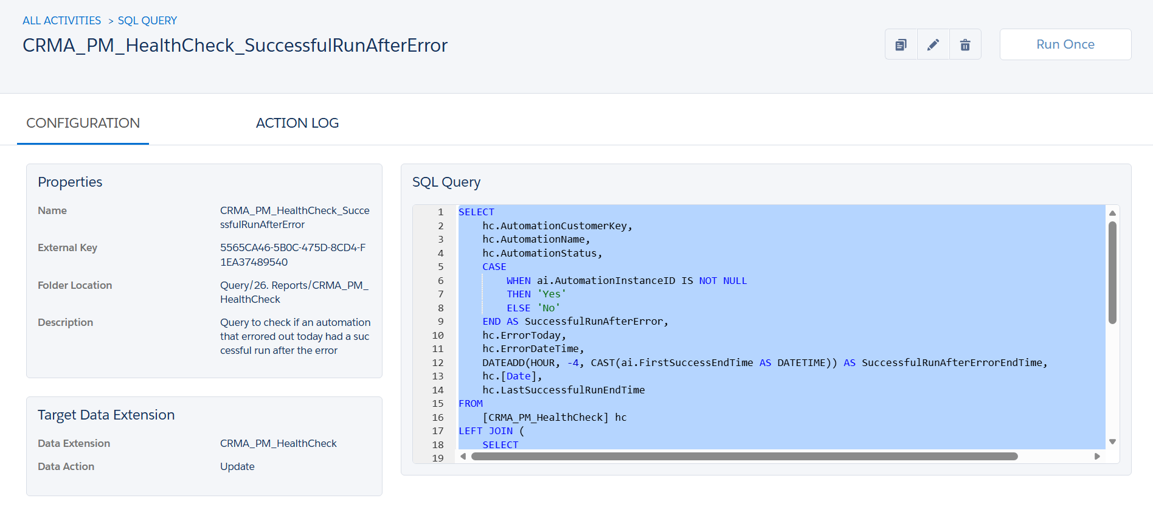
Screenshots of Data Extensions:
Source-
And _AutomationInstance as data view
Target -
data action - update
Step 6- Send Email
